Comp2147- Lab8
Name: Garv, Student ID: 101566625

ABC Company Process [Activity Diagram]:
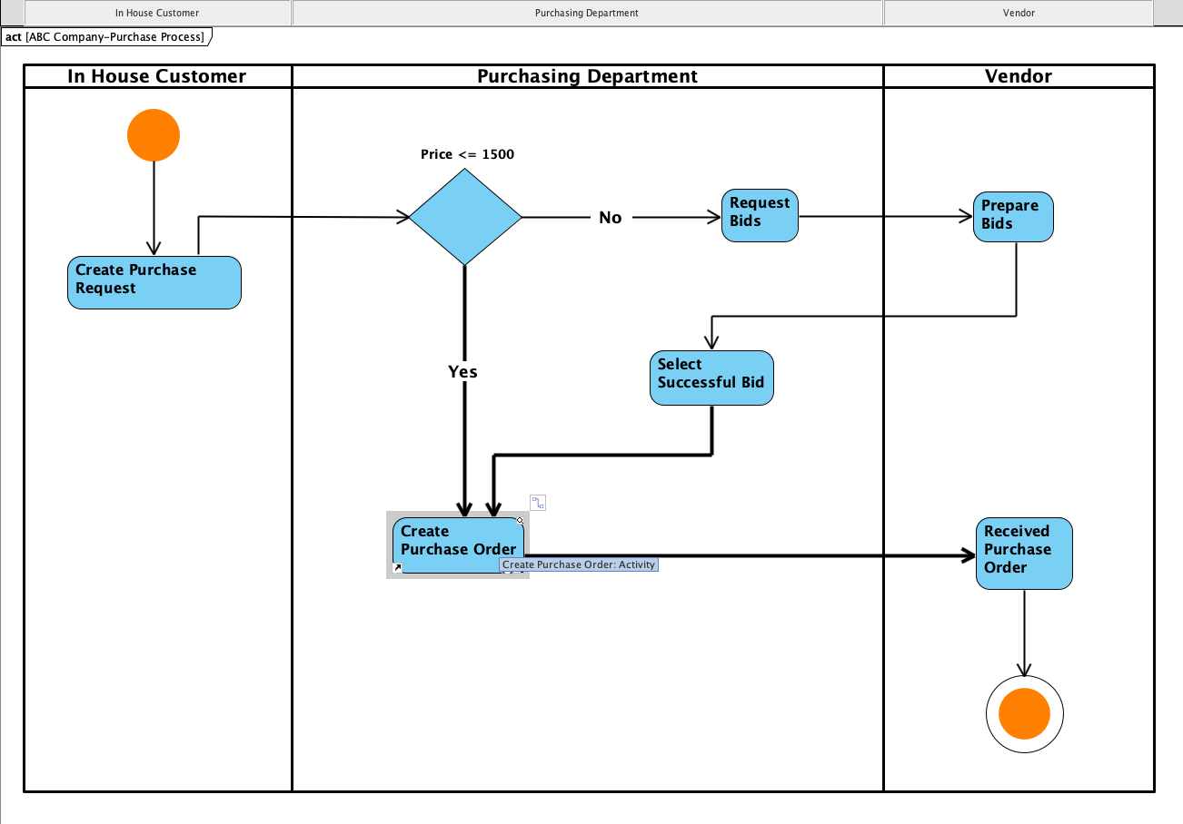

Thank-You Professor…..

